|  |  |
| --- | --- |
| Course name:  Diploma in Software and Design | |
| Assignment title | **DSD-08 Major Project** |
| Assessment weighting | *Need to pass the assessment to complete the course* |
| Passing Criteria: | Need to score 50% or more to pass the assessment.  **Total Marks : 100** |
| Due date: | **Feb 16th, 2021** |
| Assessment conditions: | This is a resource-based assessment. This means that you may have access to any relevant resources to assist you.  This could include your learning materials, information on the Internet, and so on. However, all work must be your own with no assistance from any other person. |
| Submission requirements: | Upload your project to Github or Cloud Campus |
| Module Names and Learning Outcomes: | **Major Project / Internship**   * 1. Identify and implement a software based solution that delivers measurable value to an industry or client, or identify and implement a solution to a complex problem that exists within the domain of ICTD * 2. Develop life-long learning through reflection, as demonstrated through continual reflection on the software development lifecycle (SDLC) * 3. Apply different stages of, and activities associated with, the SDLC. Demonstrate experience in all stages of the SDLC. * 4. Communicate effectively, orally and in writing, with peers, supervisors and commercial clients/stakeholders * 5. Create and exhibit prototypes or models and involve client/s and/or end users in testing the application during a software development project * 6. Explain the role and importance of project management, and configuration and risk management processes, when undertaking a software development project. Demonstrate experience in undertaking the activities associated with these. * 7. Demonstrate specialised skills in software design, development, engineering and writing in a professional software development organizational context. * 8. Participate in a group presentation, including a demonstration, to an audience of peers, clients and supervisors. |

This is an **ONLINE** only assessment. No paperwork is needed.

**Disclaimer of Plagiarism and Collusion**

I declare that:

* I have read and understood the ATC Vision Collage “Assessment Policy” and “Academic Cheating” sections as described in the Student Handbook.
* I am aware of the penalties for cheating as described in the Student Handbook.
* This assessment submission is entirely my own work, I have quoted, referenced and acknowledged any work copied directly from another source.
* I understand this assessment submission may be used for internal and/or external moderation.

I understand that if I have circumstances that affect my progress to complete assessment tasks, I will discuss it with my tutor prior to submission date

**Yoshiki Tatsumi**

**16 Feb 2021**

**Systems analysis and design**

Requirement

* To advertise upcoming concerts.
* To get more audience for the concerts with donations.
* To inform activities.
* To notify information to current members and to attract more members.
* To appeal past activities.
* To succeed the grant application and to attract more members.

Target audience

* General public who loves classical/orchestral music to attend the concerts.
* Mainly secondary school students, their parents/guardians, and music teachers for getting prospect members.
* General public and grant provider who oversees young people’s activity for providing grant / sponsoring / donation.

Research and Analysis

* Checking similar orchestra web site at Manukau Youth Orchestra at <http://www.manukauyouthorchestra.org.nz/> and comparing with current UYO web site at http://[www.unitedyouth.nz](http://www.unitedyouth.nz).
* Use the logo provided.
* Use the statement and text information provided.
* More attractive layout/colour to match the logo.
* Easy to read text/font in size and style including text decoration.

Features

* Video or audio by one of UYO’s own performance.
* Featuring Facebook logo to jump Facebook page.
* Have members only corner for informing notice and member list.
* Image gallery to appeal past activities.
* Have emailing feature on the Web page (pending).

Appearance / Style

Colour schema

* Pale green based background to match the logo, as the color of new growth on plants, it indicates immaturity, youthfulness and inexperience. It allows us to see things from a new perspective, to make a fresh start which is suitable for young group.
* Text would be dark green for the title, dark green for the menu bar, and black for texts in contents to match the logo colour.

Fonts

* Choose Arial in Sans Serif family as easy to read.
* Title: Arial in Sans Serif family, dark green colour capital bold at large size.
* Menu: Arial in Sans Serif family, dark green colour except Login, Logout, Register at medium size. Also Provide Member and Maintenance button as drop down menu.
* Body text: Arial in Sans Serif family, dark grey at medium size in general.

Logo and Brand Name

* United Youth Orchestra logo provided.
* Brand name: United Youth Orchestra

Page Content Details

Page 1: Home

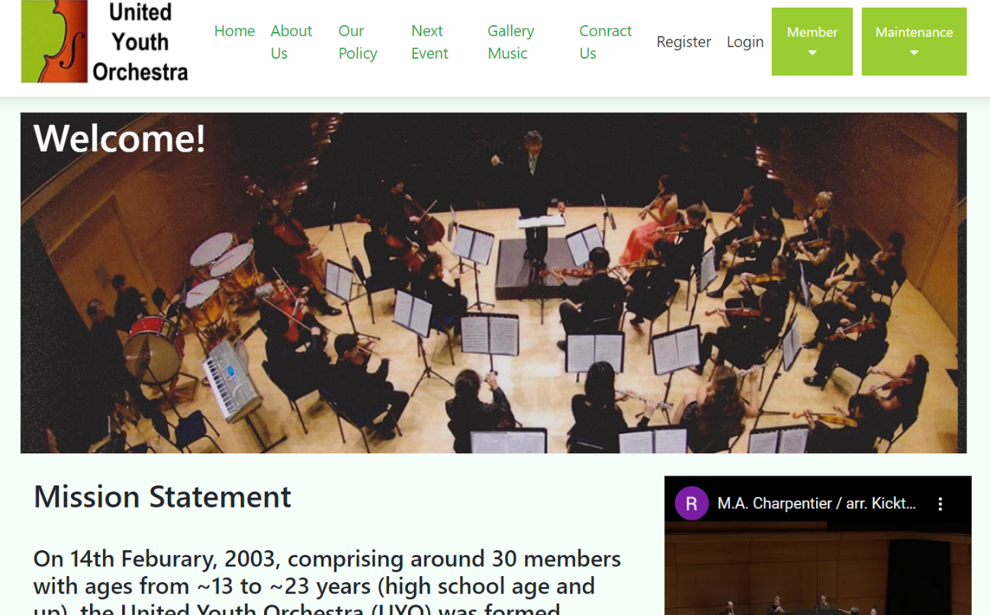

Purpose of the page 1

* This is United Youth Orchestra’s home page, which the first page that visitors will see, being their first impression of the group. There is a brief description of what the group provides and offer to the members and visitors.

Contents and Elements of page 1

* Logo
* Header: United Youth Orchestra
* Menu bar: Home, About Us, Our Policy, Next Event, Gallery / Music, Contact Us, Register, Login with Drop down menu: Member, Maintenance.
* Main photo
* Mission statement.
* Past concert in YouTube embedded.
* Music Director and Orchestra Leader.
* Footer: Logo, Facebook button to jump, Get in Touch, Copyright.

Page 2: About Us

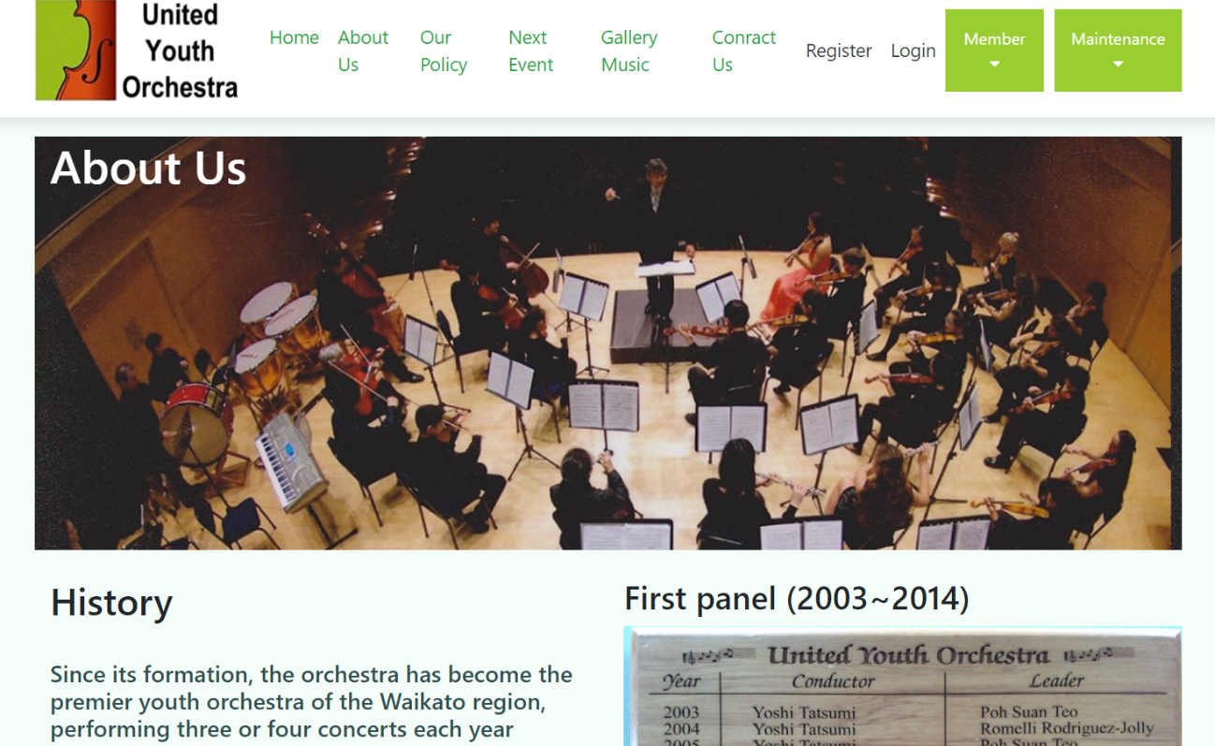

Purpose of the page 2

* On the About Us page, it provides the group’s history and activity.

Contents and Elements of page 2

* Logo
* Header: United Youth Orchestra
* Menu bar: Home, About Us, Our Policy, Next Event, Gallery / Music, Contact Us, Register, Login with Drop down menu: Member, Maintenance.
* Main photo
* Brief history.
* Board of Conductor/Leader.
* Past activity certificates.
* Footer: Logo, Facebook button to jump, Get in Touch, Copyright.

Page 3: Our Policy

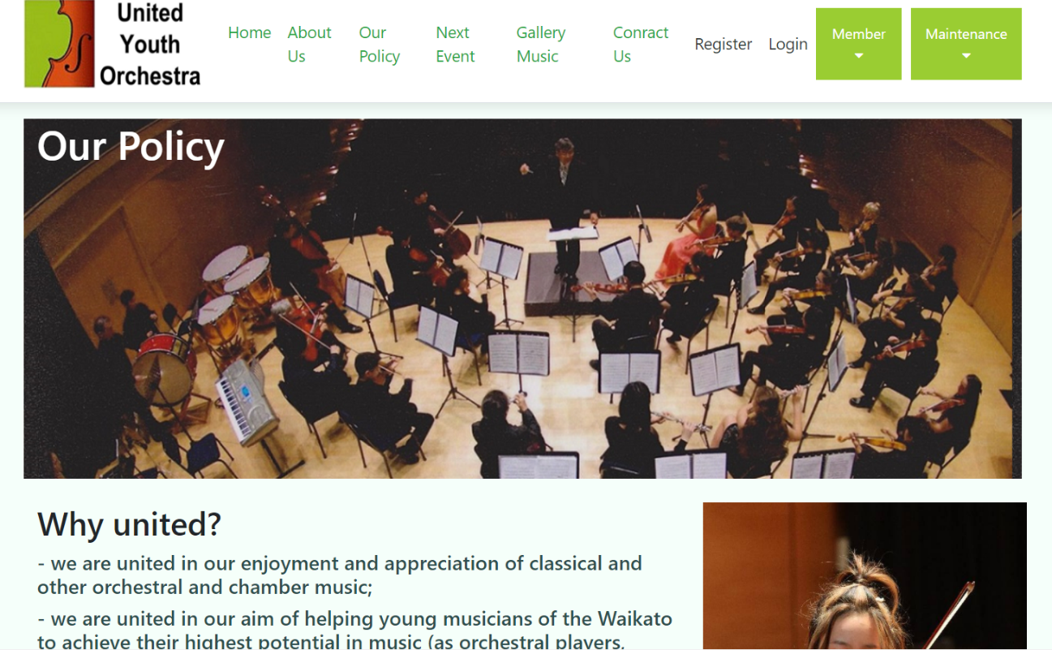

Purpose of the page 3

* On the Our Policy page, it provides UYO’s Policy.

Contents and Elements of page 3

* Logo
* Header: United Youth Orchestra
* Menu bar: Home, About Us, Our Policy, Next Event, Gallery / Music, Contact Us, Register, Login with Drop down menu: Member, Maintenance.
* Main photo
* Policy – Why united?
* General activities.
* Footer: Logo, Facebook button to jump, Get in Touch, Copyright.

Page 4: Next Event

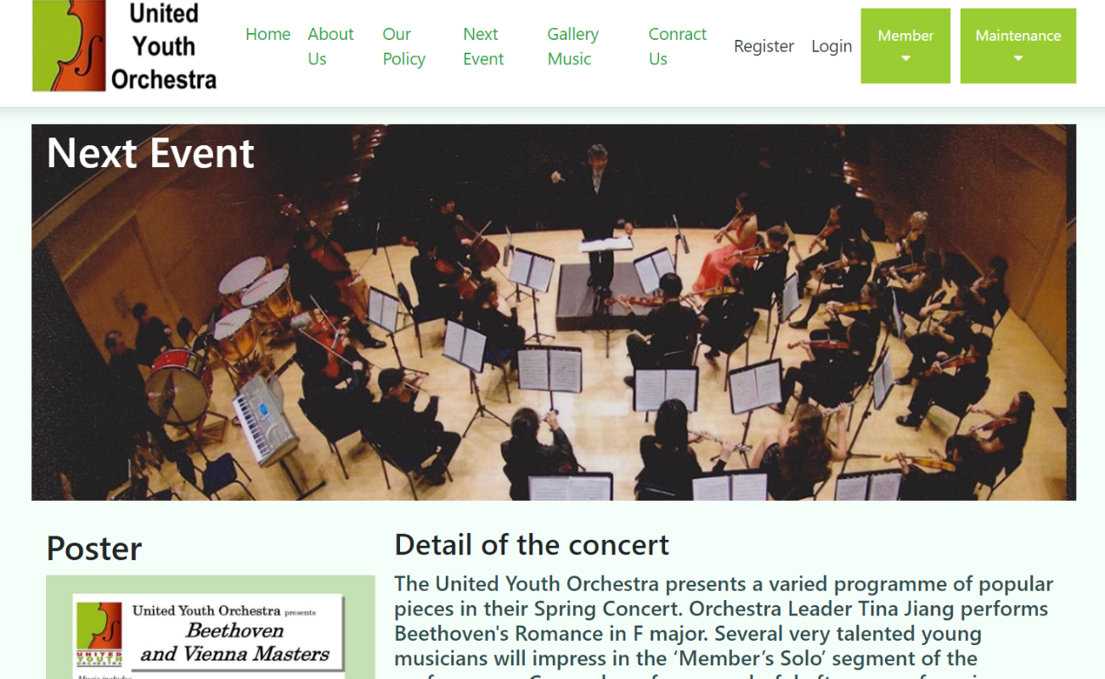

Purpose of the page 4

* On the Next Event page, it provides information of next event in general.

Contents and Elements of page 4

* Logo
* Header: United Youth Orchestra
* Menu bar: Home, About Us, Our Policy, Next Event, Gallery / Music, Contact Us, Register, Login with Drop down menu: Member, Maintenance.
* Main photo
* Next concert poster and details.
* Upcoming Activities.
* Footer: Logo, Facebook button to jump, Get in Touch, Copyright.

Page 5: Gallery / Music

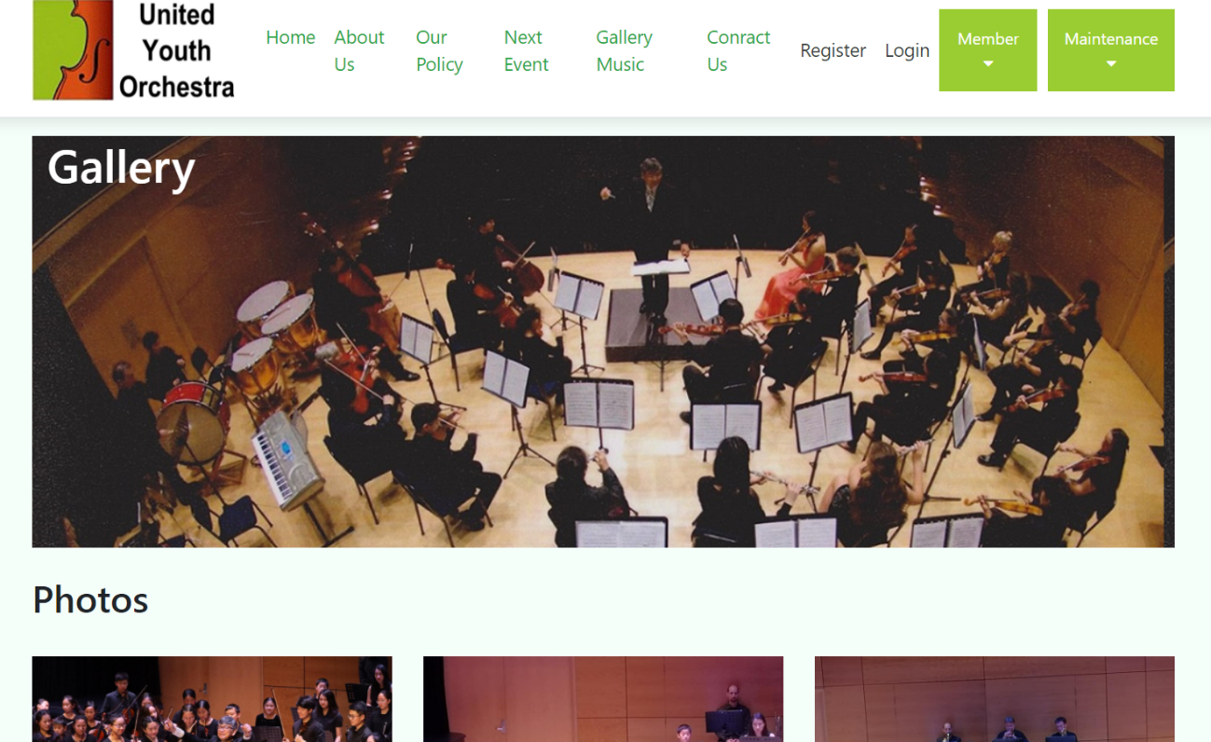

Purpose of the page 5

* On the Gallery / Music page, it provides information of past activities.

Contents and Elements of page 5

* Logo
* Header: United Youth Orchestra
* Menu bar: Home, About Us, Our Policy, Next Event, Gallery / Music, Contact Us, Register, Login with Drop down menu: Member, Maintenance.
* Main photo
* Photo gallery of past concert/activities.
* Past music list.
* Footer: Logo, Facebook button to jump, Get in Touch, Copyright.

Page 6: Contact Us

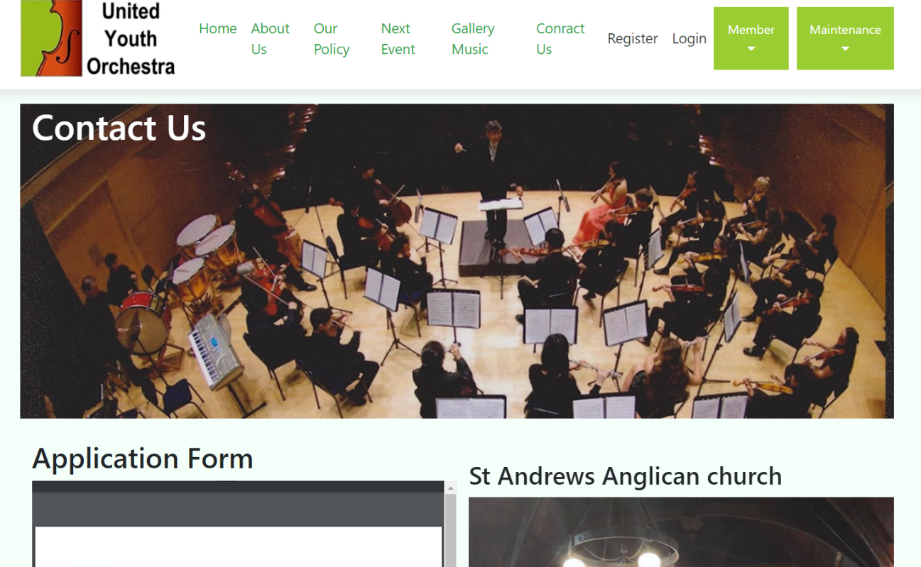

Purpose of the page 6

* On the Contact Us page, it provides information of how to apply and contact us.

Contents and Elements of page 6

* Logo
* Header: United Youth Orchestra
* Menu bar: Home, About Us, Our Policy, Next Event, Gallery / Music, Contact Us, Register, Login with Drop down menu: Member, Maintenance.
* Main photo
* Application Form
* Some concert venue photos.
* On-site email (pending).
* Footer: Logo, Facebook button to jump, Get in Touch, Copyright.

Page 7: Register

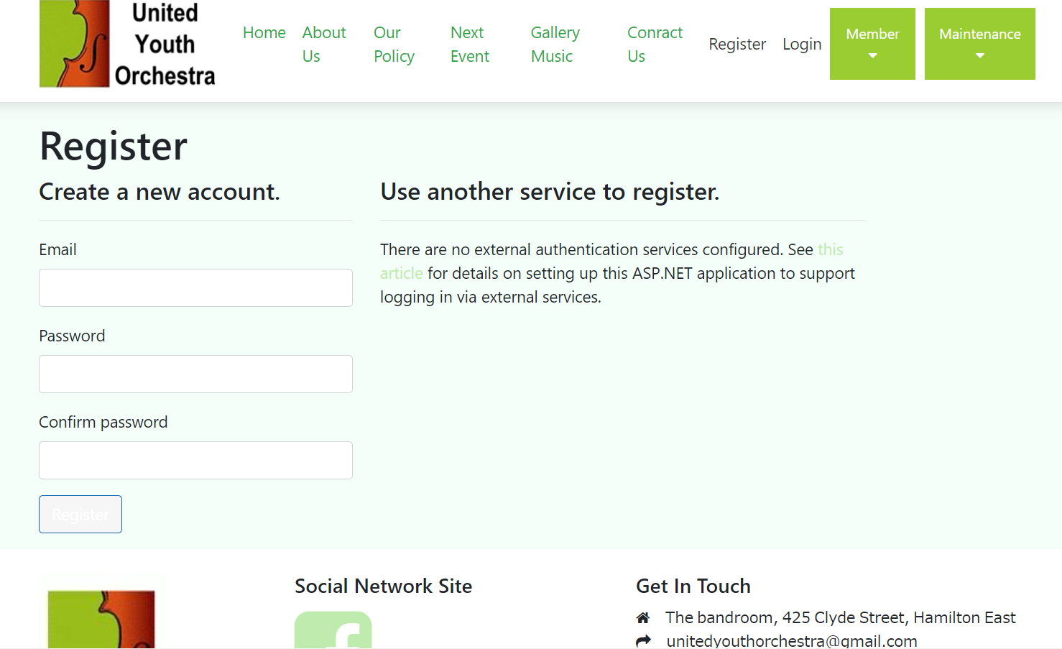

Purpose of the page 7

* On the Register page, members are welcome to register.

Contents and Elements of page 7

* Logo
* Header: United Youth Orchestra
* Menu bar: Home, About Us, Our Policy, Next Event, Gallery / Music, Contact Us, Register, Login with Drop down menu: Member, Maintenance.
* Register table including name, email, password and confirm password.
* Footer: Logo, Facebook button to jump, Get in Touch, Copyright.

Page 8: Login

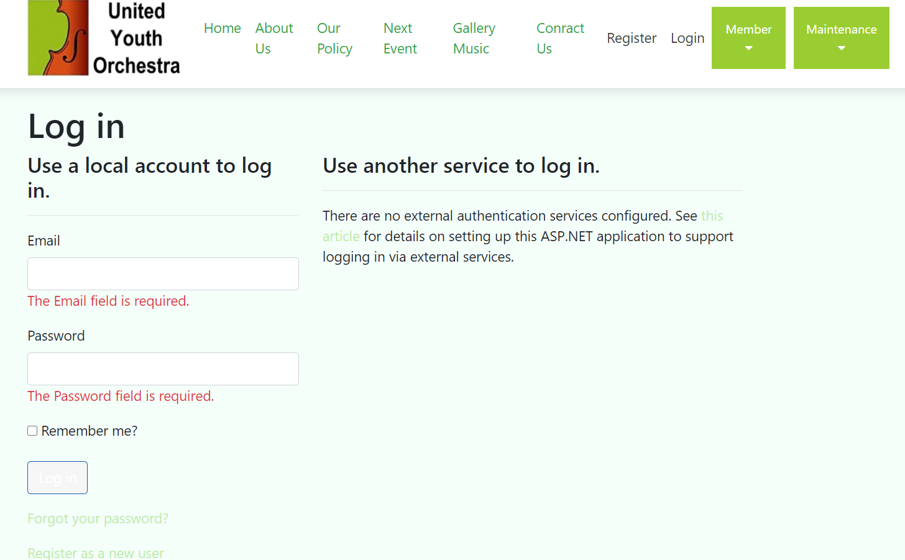

Purpose of the page 8

* On the Login page, members are welcome to login and get more information.

Contents and Elements of page 8

* Logo
* Header: United Youth Orchestra
* Menu bar: Home, About Us, Our Policy, Next Event, Gallery / Music, Contact Us, Register, Login with Drop down menu: Member, Maintenance.
* Login table including email and password.
* Footer: Logo, Facebook button to jump, Get in Touch, Copyright.

Page 9: Notice under Member Drop down menu.

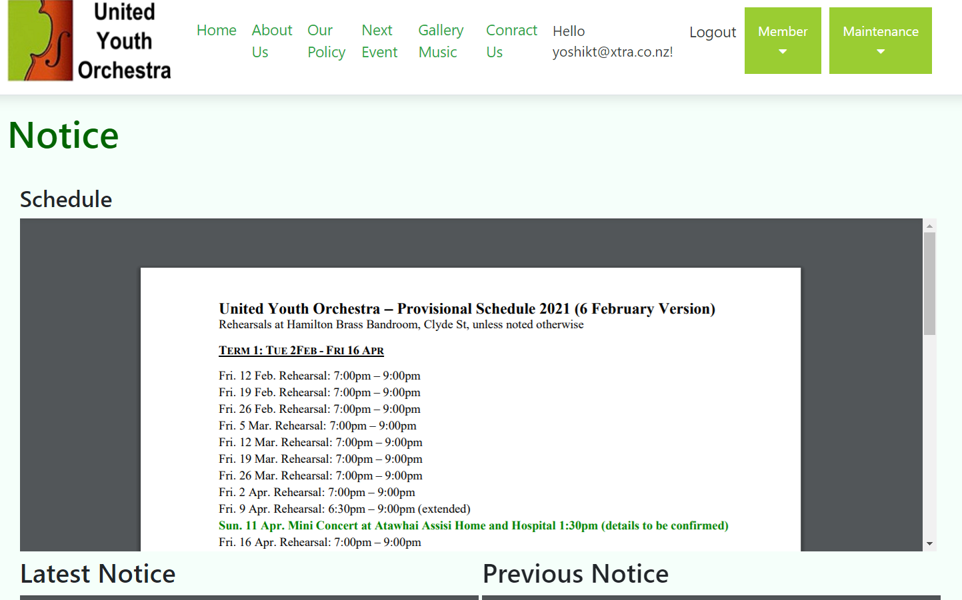

Purpose of the page 9

* On the Notice page, members get more information.

Contents and Elements of page 9

* Logo
* Header: United Youth Orchestra
* Menu bar: Home, About Us, Our Policy, Next Event, Gallery / Music, Contact Us, Register, Login with Drop down menu: Member, Maintenance.
* Schedule.
* Notice (Latest and previous).
* Footer: Logo, Facebook button to jump, Get in Touch, Copyright.

Page 10: Member under Member Drop down menu.

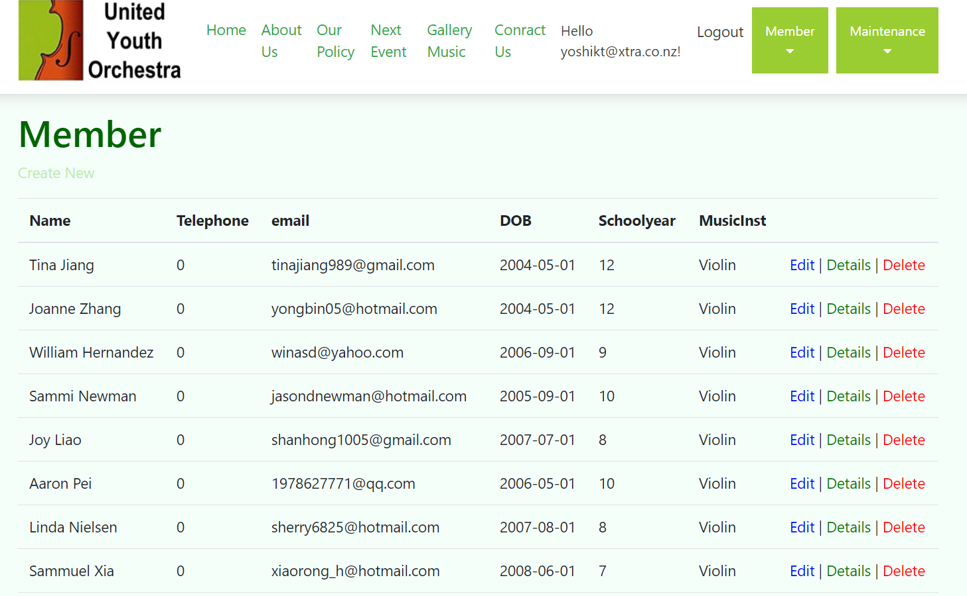

Purpose of the page 10

* On the Member page, members can get the information of membership listed and can add/edit the information.

Contents and Elements of page 10

* Header: United Youth Orchestra
* Menu bar: Home, About Us, Our Policy, Next Event, Gallery / Music, Contact Us, Register, Login with Drop down menu: Member, Maintenance.
* Member.
* Footer: Logo, Facebook button to jump, Get in Touch, Copyright.

Page 11: Instrument under Maintenance Drop down menu.

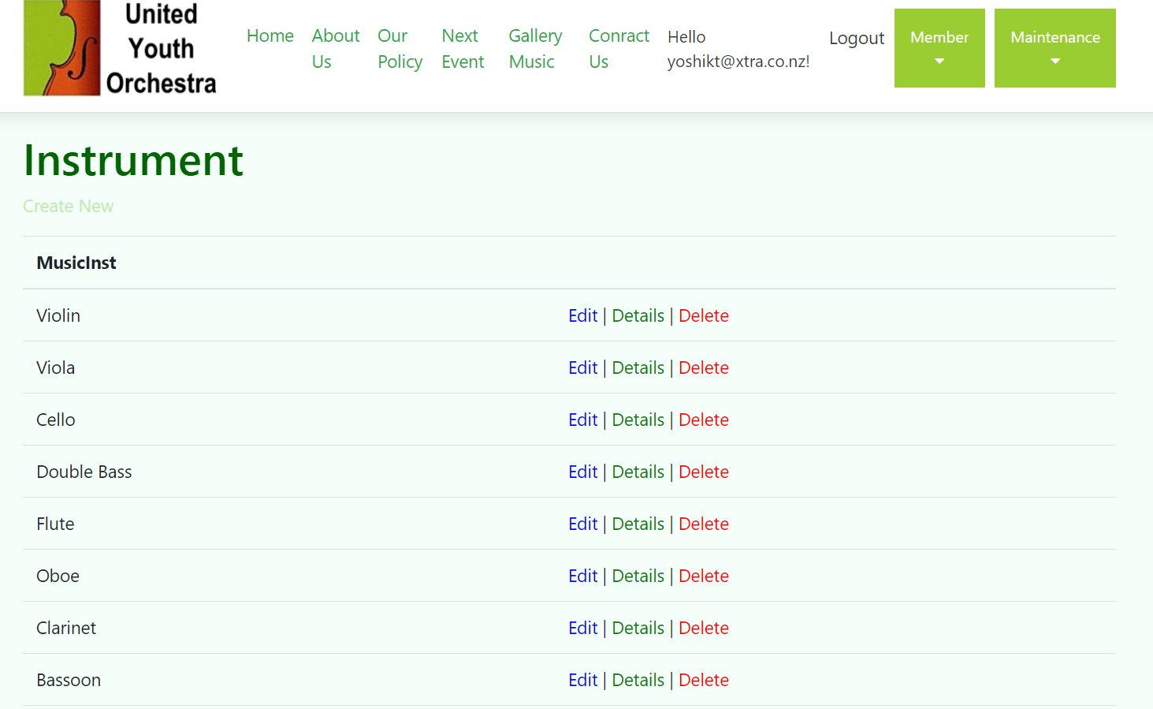

Purpose of the page 11

* On the Instrument page, administrator can add/edit the information.

Contents and Elements of page 11

* Header: United Youth Orchestra
* Menu bar: Home, About Us, Our Policy, Next Event, Gallery / Music, Contact Us, Register, Login with Drop down menu: Member, Maintenance.
* Instrument.
* Footer: Logo, Facebook button to jump, Get in Touch, Copyright.

Page 12: School Year under Maintenance Drop down menu.

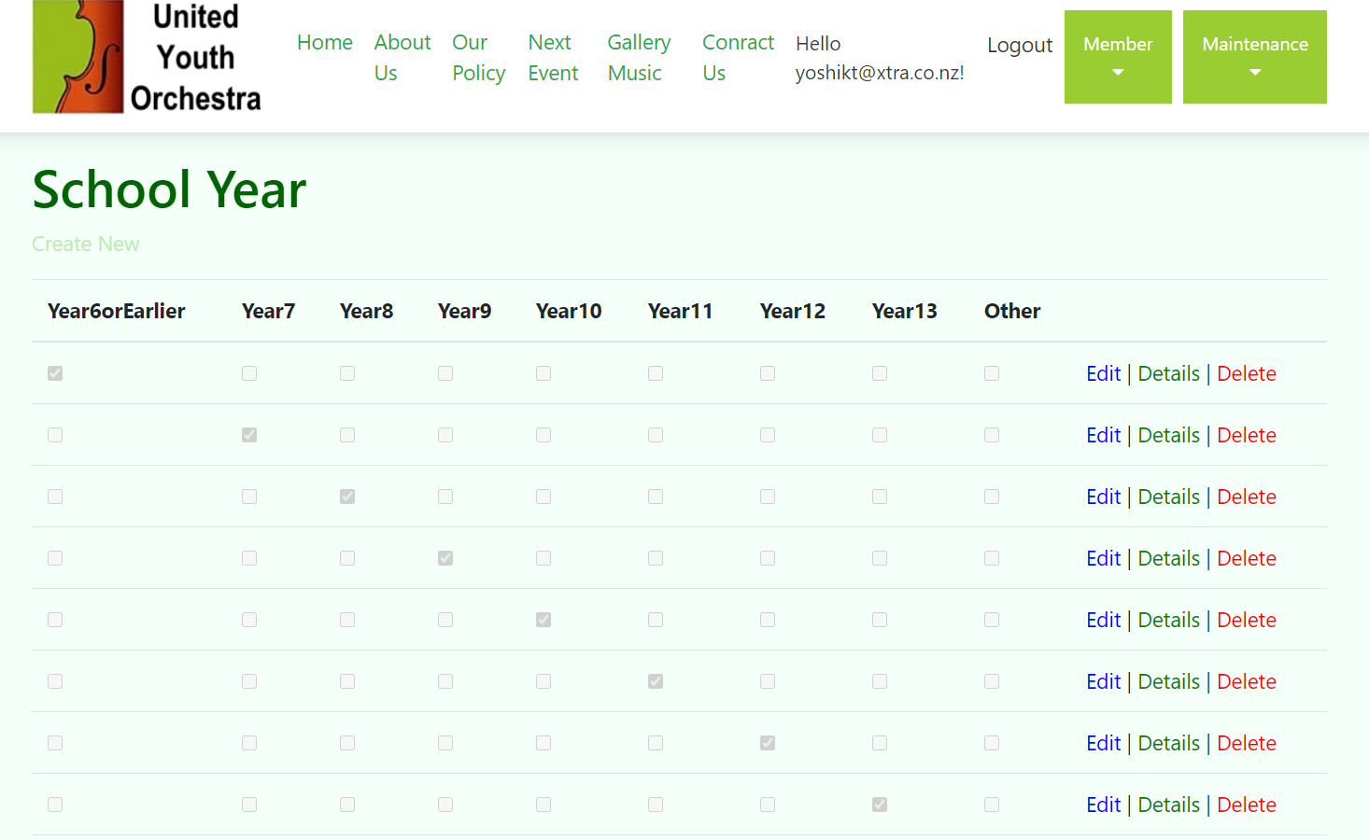

Purpose of the page 12

* On the School Year page, administrator can add/edit the information.

Contents and Elements of page 12

* Header: United Youth Orchestra
* Menu bar: Home, About Us, Our Policy, Next Event, Gallery / Music, Contact Us, Register, Login with Drop down menu: Member, Maintenance.
* School Year.
* Footer: Logo, Facebook button to jump, Get in Touch, Copyright.

Site map

* The relationship pf each page is as below.

